The Broadcaster ▪ August 12, 2020 ▪ 715-432-6285 ▪ stoneyacrescsa@gmail.com ▪ www.stoneyacresfarm.net
“Shite and Onions!”
--James Joyce

News from the Farm
CSA Week 11, 2020! Joining a CSA is about so many things, like local food, supporting small farms, taking care of the environment. At the heart, though, is eating well. This week your box represents the peak of summer vegetables and I know that you will have so many options for delicious meals! You can use your ingredients to make a fresh salsa, tomato salad, or ratatouille. I’ve been harvesting with two main farm hands, Brian Johnson and Alex Radtke during this season. Brian has a lot of experience on dairy farms, and he has transitioned well to Stoney Acres diversified environment. He handles getting run over by a cow like a professional rodeo clown! Alex has made himself indispensable during his first season. He helps me load up the truck at 5 AM before the farmer’s market, and is willing to shave his head into a “Friar Tuck” hairstyle. What more could I ask for? In all seriousness, though, I value the labor that these two provide, and the CSA benefits from them so much. Thank you, Brian and Alex! We have been making the best out of the summer. My sister and her two kids came for a visit, and we spent time swimming, playing basketball in the hay mow (Ted and I won against Dana and Riley after they beat us last time we played), and swimming in Harper’s lake. Maple has become the kitten whisperer. Katie is coming for a visit this week. Life is good!
--Have a delicious week- Tony, Katie, Riley, Ted, & Maple
In Your Box
Sage or Parsley
Peppers
Cucumbers
Zucchini
Onions
Corn
Carrots
Cilantro
Tomatoes
Cherry Tomatoes

Next Week’s Best Guess: Cucs, zucs, peppers, corn, onions, tomatoes, cilantro, potato, garlic, cherry tomatoes
Pizza specials of the Vegginald Vel-Johnson- Fennel, zucchini, broccoli, onions. Ben Franklin Soaking Food – Stoney sausage, peppers, caramelized onions, ajued oyster mushrooms. Blue Oyster Cult – Carr valley blue cheese, stoney sausage, ajued oyster mushrooms, garlic sauce Sweet Honey n’ the Bock – Bacon, chevre, heirloom tomatoes, honey, and fresh ground pepper. Scapegoat—Goat cheese from laclare farm, garlic scape pesto, flecked ham, and roasted garlic scapes in post. Holy Shitake—Sausage, shitake mushrooms, roasted fennel, parm form harmony dairy in post. . Margherita—Fresh basil, heirloom tomatoes, fresh mozz, and basil pesto
Farm to Table Recipes Gleaned by Tony and Katie
Cilantro Vinagrette (pinch of yum) (insert disparaging comment about cilantro here—Katie):
1 huge bunch of fresh cilantro (2 cups packed), 1/2 cup olive oil, 2 tablespoons white vinegar, 1 clove garlic, 1 teaspoon kosher salt, 1/2 teaspoon red pepper flakes, 1/4 to 1/2 cup water, if needed
Blend everything up for about a minute until smooth. Add the water if you need more volume in the blender to make it run smoothly. Season to taste!
Tomato Salad (The Kitchn) 1 small or 1/2 medium red onion, thinly sliced into half-moons, 1 1/2 pounds heirloom tomatoes (about 3 medium tomatoes), 1/4 cup packed fresh herbs, such as basil, cilantro, dill, parsley, or a combination, coarsely chopped, 2 tablespoons extra-virgin olive oil, 1 tablespoon, red wine vinegar, 1/2 teaspoon kosher salt, 1/4 teaspoon , freshly ground black pepper
Ratatouille’s Ratatouille
As envisioned by Smitten Kitchen
1/2 onion, finely chopped
2 garlic cloves, very thinly sliced
1 cup tomato puree (such as Pomi)
2 tablespoons olive oil, divided
1 small eggplant (my store sells these “Italian Eggplant” that are less than half the size of regular ones; it worked perfectly)
1 smallish zucchini
1 smallish yellow squash
1 longish red bell pepper
Few sprigs fresh thyme
Salt and pepper
Few tablespoons soft goat cheese, for serving
Preheat oven to 375 degrees F.
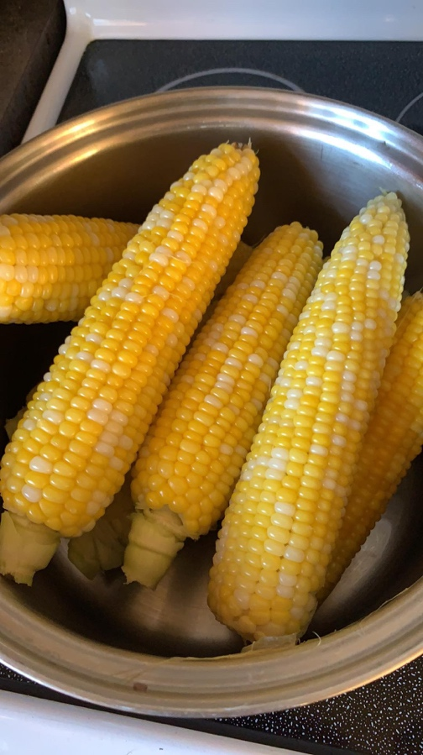
Pour tomato puree into bottom of an oval baking dish, approximately 10 inches across the long way. Drop the sliced garlic cloves and chopped onion into the sauce, stir in one tablespoon of the olive oil and season the sauce generously with salt and pepper. Trim the ends off the eggplant, zucchini and yellow squash. As carefully as you can, trim the ends off the red pepper and remove the core, leaving the edges intact, like a tube. On a mandoline, adjustable-blade slicer or with a very sharp knife, cut the eggplant, zucchini, yellow squash and red pepper into very thin slices, approximately 1/16-inch thick.Atop the tomato sauce, arrange slices of prepared vegetables concentrically from the outer edge to the inside of the baking dish, overlapping so just a smidgen of each flat surface is visible, alternating vegetables. You may have a handful leftover that do not fit. Drizzle the remaining tablespoon olive oil over the vegetables and season them generously with salt and pepper. Remove the leaves from the thyme sprigs with your fingertips, running them down the stem. Sprinkle the fresh thyme over the dish.Cover dish with a piece of parchment paper cut to fit inside. (Tricky, I know, but the hardest thing about this.)
Bake for approximately 45 to 55 minutes, until vegetables have released their liquid and are clearly cooked, but with some structure left so they are not totally limp. They should not be brown at the edges, and you should see that the tomato sauce is bubbling up around them.Serve with a dab of soft goat cheese on top, alone, or with some crusty French bread, atop polenta, couscous, or your choice of grain.

