The Broadcaster ▪ July 8, 2020 ▪ 715-432-6285 ▪ stoneyacrescsa@gmail.com ▪ www.stoneyacresfarm.net
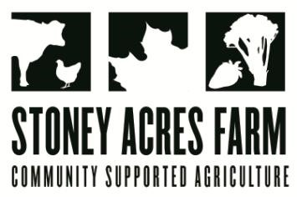
“A man taking basil from a woman will love her always.”
--Thomas More
News from the Farm
CSA Week 6, 2020! One word to describe the last week: productive! We spent the week renovating one of the hoop houses into melon house! We had beautiful melon transplants, and they’re in the ground, growing, and with the hot stretch that we have been having, should be incredible at harvest! This is the best corn year that I have ever had! Unfortunately, I often struggle to grow corn. It suffers from a beef blight. The cows seem 17% less naughty than last year, though, so I am hopeful that you will have corn in your share this year! Besides that, they seem to be developing a preference for brussel sprouts. I trellised the tomatoes and peppers with Alex, and we did a big harvest. Ted harvested the first tomato—a Brandywine! The basil exploded this week! You’ll see it in your share this week and probably next, too. I have dedicated a hoop house to basil because it is so important for pizza. We spent the week (wait for it…)… weeding! We did a lot of manual weeding, but I also pulled out our flame weeder. This tool really helps to control weeks without using harmful chemicals. And, it’s fun to use. This hot stretch has been good for the plants, and good for us, too! We’re finding time to play. Riley and Ted beat me at basketball for the first time, and Maple and I cooled off playing in the water at Amco Park. Summer is here! Have a delicious week- Tony, Riley, Ted, Maple, Toby, Stout, & Marble Cake

In Your Box
Fennel
Garlic Scapes
Lettuce Heads
Napa Cabbage
Kohlrabi
Basil
Chard
Peas
Zucchini (Fulls)

Next Week’s Best Guess: broccoli, kale, basil, kohlrabi, garlic scapes, cucumbers, zucchini, peppers
Pizza specials of the Vegginald Vel-Johnson- Charred kale, roasted fennel, roasted cherry tomatoes, garlic sauce. Ben Franklin Soaking Food – Stoney sausage, peppers, caramelized onions, ajued oyster mushrooms. It’s all Clover Now Baby Blue – Kale, ham, Blue Cheese, scallions, and Marathon red clover in post Blue Oyster Cult – Carr valley blue cheese, stoney sausage, ajued oyster mushrooms, garlic sauce Charred Chard – Flecked ham, roasted cherry tomatoes, roasted fennel, charred chard. Scapegoat—Goat cheese from laclare farm, garlic scape pesto, flecked ham, and roasted garlic scapes in post.
Farm to Table Recipes Gleaned by Tony and Katie (and in this case, the always-delightful Heather Busig)
Zucchini Quesadillas (from smitten kitchen)! INGREDIENTS: 3 tablespoons olive oil, plus more for frying quesadillas, 2 to 3 garlic cloves, thinly sliced, 1/2 teaspoon mild (aleppo) or hotter red pepper flakes, 1 1/2 pounds zucchini or other slim summer squash, halved and thinly sliced, Kosher salt, 1 lime, halved, 6 ounces grated monterey jack cheese, 12 6-inch corn tortillas, Sliced avocado, chopped fresh cilantro (OR NOT!), additional lime, and thinly sliced jalapeno to finish.

Heat a large skillet over medium. Once hot, add oil. Once oil is hot, add garlic and cook, stirring about 1 minute. Add zucchini, 1 t. kosher salt, and red pepper flakes and increase heat to medium-high. Cook until zucchini becomes soft, about 5 minutes. Reduce heat and cook 7 to 10 minutes more until very tender. Add the juice of half your lime, scrape mixture into a wide bowl. Let cool, then add cheese to zucchini mixture and mix. Lay out 6 of your tortillas and divide the filling between them, going all the way to the edges. Place remaining 6 tortillas on top. Heat the skillet over medium and add a couple t. of oil. Transfer your assembled quesadillas to the skillet and cook until both sides are deeply golden and crisp underneath.

What did the mama cow say to the baby cow? It’s pasture bedtime.
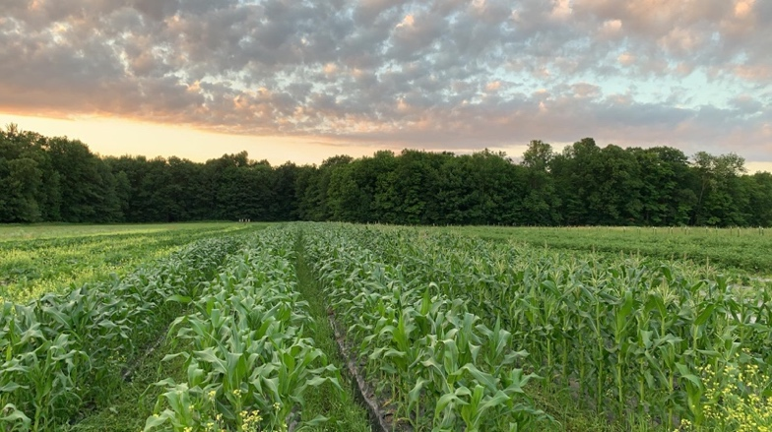
What do you call a fast fungus?
A mush-vroom
Why did the grape stop in the middle of the road?
Because he ran out of juice.
Why did the Tomato go out with a prune?
Because he couldn’t find a date!
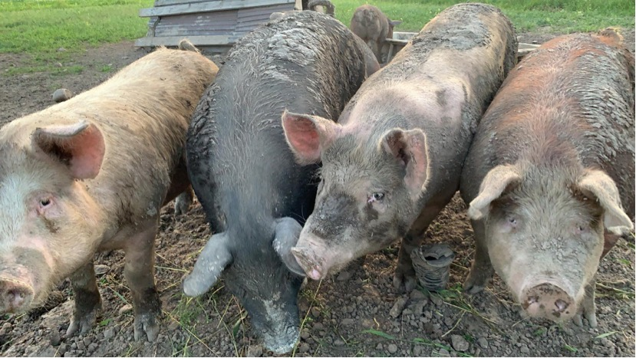
What did the father tomato say to the baby tomato whilst on a family walk?
Ketchup.
What vegetables are a sailors enemy?
leeks!
Why did the tomato blush?
Because he saw the salad dressing
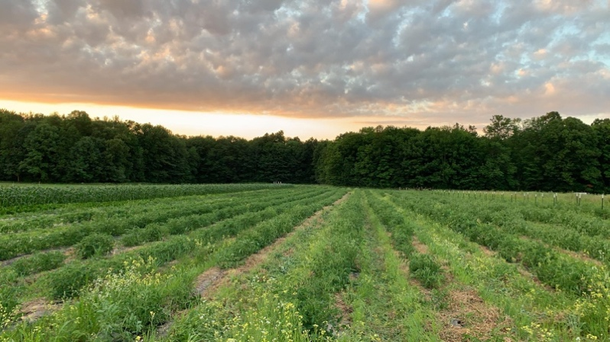
Why do fungi have to pay double bus fares?
Because they take up too mushroom
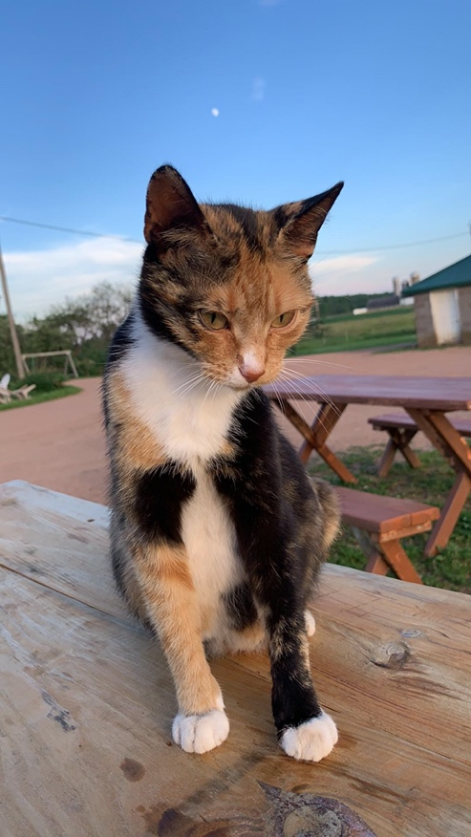
Knock, Knock
Who’s there?
Lettuce
Lettuce Who?
Lettuce in and you’ll find out
Why do potatoes always argue?
Because they can never see eye to eye.
Why shouldn’t you tell secrets in a cornfield?
There are too many ears!
What is small, red and whispers?
A hoarse radish!
What did the lettuce say to the celery? Quit stalking me!
How does a hen leave the house? Through the egg-sit.
Being a farmer isn’t for everyone, but hay, it’s in my jeans.

