The Broadcaster ▪ July 15, 2020 ▪ 715-432-6285 ▪ stoneyacrescsa@gmail.com ▪ www.stoneyacresfarm.net
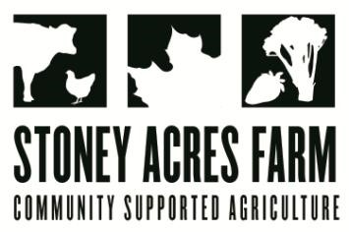
“To see cucumbers in a dream denotes that you will speedily fall in love. Or, if you are in love, then you will marry the object of your affection.”
--Richard Folkard in 'Plant Lore' (1884)

News from the Farm
CSA Week 7, 2020! Ted Turns Ten! Ted, affectionately called to-tetrahedron, tedron, and Teddy (by his older brother), has officially entered the double digits! Ted is contemplative, hilarious, a rascally younger brother to Riley, and a rambunctious friend to Maple. We are celebrating Ted today with steak for lunch, loads of veggies, and a cookies and cream pie for dessert. Ted has an important role on our family farm. He is knowledgeable about planting, and he is already an outstanding greenhouse man. I love spending time in the greenhouse with him! Ted always prompts philosophical conversations! He is a master at all games, but especially monopoly; he is a connoisseur of superhero movies. Mostly, he makes our lives richer and more hilarious. Happy Birthday Ted! This week has been a wet one. Well, Tuesday was wet. Four and a half inches of rain in one day went beyond a healthy soaking rain, and will impact some crops around the edges of the fields. Clearly the weather does not understand my desire to have an appropriately soaking rain of one inch between 3-6 AM on Sunday morning only. I spent the rainy day with Brian and Hen-Ben pulling the last of the concrete out of the barn. Today is dedicated to harvesting kale, broccoli, and peppers for your boxes. The corn is tall. This is the best corn year ever. Everyone who walks into the cornfields measures themselves against the corn, and the corn is always taller. Everything is growing! Have a delicious week- Tony, Riley, Ted, Maple, Toby, Stout, & Marble Cake

In Your Box
Kale
Garlic Scapes
Napa Cabbage
Peppers
Carrots
Cucumbers
Broccoli
Zucchini

Next Week’s Best Guess: carrots, garlic scapes, fennel, kohlrabi, lettuce heads, cucumbers, zucchini
Pizza specials of the Vegginald Vel-Johnson- Charred kale, roasted fennel, roasted cherry tomatoes, garlic sauce. Ben Franklin Soaking Food – Stoney sausage, peppers, caramelized onions, ajued oyster mushrooms. Blue Oyster Cult – Carr valley blue cheese, stoney sausage, ajued oyster mushrooms, garlic sauce Charred Chard – Flecked ham, roasted cherry tomatoes, roasted fennel, charred chard. Scapegoat—Goat cheese from laclare farm, garlic scape pesto, flecked ham, and roasted garlic scapes in post. Holy Shitake—Sausage, shitake mushrooms, roasted fennel, parm form harmony dairy in post.
Farm to Table Recipes Gleaned by Tony and Katie
The theme of this week is guilty-pleasure salads that are easy to make and great for when it is sweltering hot outside. Yes--you tried these salads first at a pot-luck, and maybe thought they were a little weird, but surprisingly tasty. Absolve yourself of creamy-mayonnaisey-guilt! Enjoy!

Creamy cucumber salad: This is a really quick and easy, refreshing summer side dish. 1/2 cup Sour cream, 2 tbsp Fresh dill (dried works, too), 1 tbsp , 1 tbsp Lemon juice, 1/2 tsp Garlic powder, 1/2 tsp Sea salt, 1/4 tsp Black pepper, 6 cups Cucumber (chopped), 1 small onion (thinly sliced). Mix dressing ingredients, and stir over sliced cucumbers and onions.
Broccoli salad: 2 heads fresh broccoli, 1 red onion, ½ pound bacon, ¾ cup raisins or craisins, ¾ cup sliced almonds, 1 cup mayonnaise , ½ cup white sugar (or better yet, maple syrup) 2 tablespoons white wine vinegar. Cook bacon until crispy and chop. Cut broccoli into bite size pieces. Mix remaining ingredients into a dressing.

You’ve got Kale!
In honor of TED’s TENTH, here are TEN facts about Kale!
- Kale is a member of the cabbage family, along with cabbage and Brussel sprouts.
- Kale is such a popular vegetable in Scotland that being invited to “come to kale” was an invitation to dinner.
- It's not a new kid on the block: Kale is popular now, but people have been growing this super food for more than 2,000 years. Popular in Europe during Roman times and the Middle Ages, it arrived in the U.S. in the 17th century.
- Kale chips are a simple, good-for-you snack. Remove kale leaves from stems, tear into bite-sized pieces, drizzle with olive oil and a dash of salt, and bake 10 to 15 minutes in a 400 F oven.
- Kale Is Loaded With Powerful Antioxidants Like Quercetin and Kaempferol.
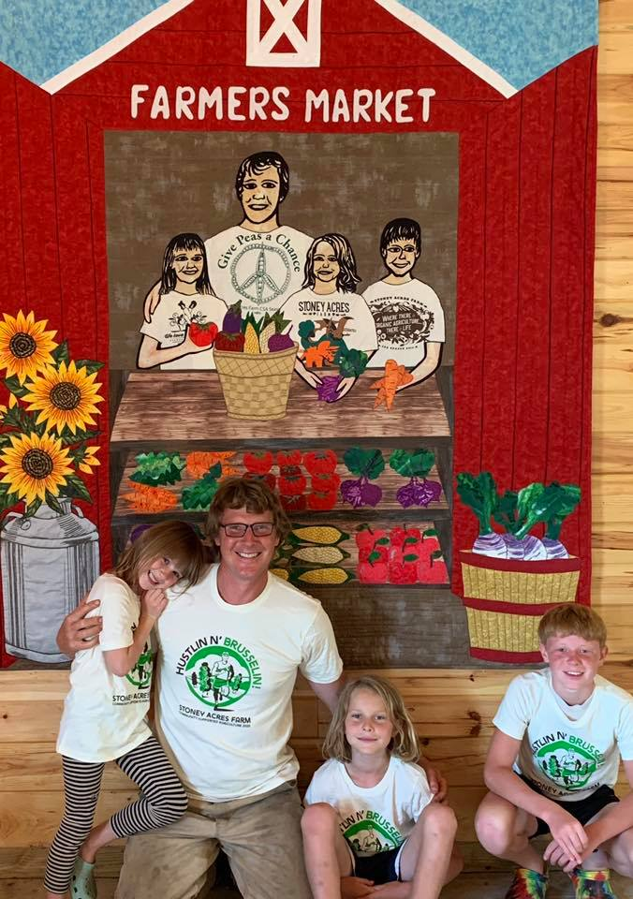
- One cup of chopped raw kale provides more than 100% of the recommended daily amount of vitamins A and K.
- For the best flavor, kale must be harvested after the first frost. This ensures that some of the starches have turned into sugars.
- Types of kale are marked by color (green, white, purple, or bluish green) and leaf shape.
- Kale contains lutein, a nutrient that helps create the plant’s color. Lutein helps keep eyes and vision healthy.
- Kale lends itself well to puns like “You’ve got Kale” and “It kales me to have you leaf so soon.”

